**Question 1A**  
Assume the existence of an economy consisting of identical consumers each with the following utility function: $U = x^{0.4}y^{0.6}$.  
Further suppose there is only one factor of production, Labour (L). It takes 5 units of labour to produce one unit of x and 10 units of labour to produce one unit of y, and there are 1000 units of labour available.  
Please answer the following questions (using diagrams where appropriate):

1. **Write the equation for the Production Possibilities Frontier (PPF) and plot it on a diagram. Why does it have this particular shape, and what factors, in general, will affect the shape of a PPF? (8 + 7 = 15 marks)**

The equation for the PPF is: $5x+10y=1000$. When this equation is satisfied, all factor inputs are being fully utilised.

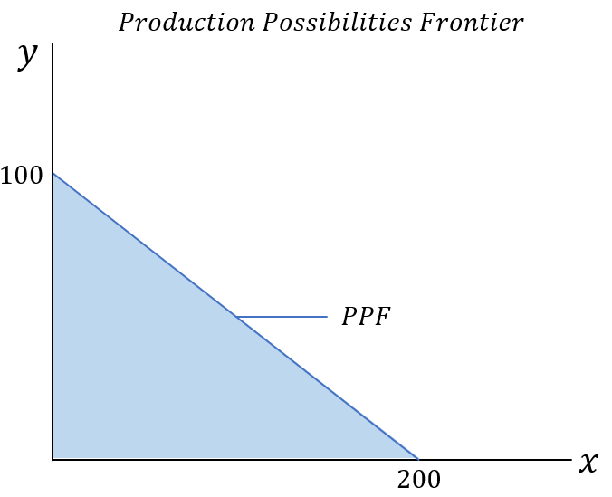

Figure 1

Figure 1 plots the PPF for this equation. When none of good $y$ is produced, 200 $x$ is produced with all 1000 units of labour. Conversely, 100 $y$ is produced with all 1000 units of labour.

The PPF has this shape, i.e., a negative constant slope $=-\frac{1}{2}$, because of a few important reasons. First, both goods $x$ and $y$ display constant returns to scale with labour: If we take $L$ to be one unit of labour, then $5L=x$ and $10L=y$. Calculating $\frac{∂x}{∂L}$ and $\frac{∂y}{∂L}$, we get $\frac{1}{5}$ and $\frac{1}{10}$, which are constant values unrelated to the existing labour expenditure; this fact combines with the fact that we are in a single input case, i.e., we do not take into account capital, to produce a straight-line graph. If the production equations for goods $x$ or $y$ had increasing returns to scale, e.g., $5L^{2}=x$, then the PPF would be convex. Second, different PPFs are possible if different production techniques are available. At the moment, only one technique is available. However, a different technique which produced $y$ more efficiently at the expense of producing $x$ less efficiently, say $7x+7y=1000$, would introduce a kink in the PPF where the total output between techniques was equal.

1. **What are the Pareto optimal levels of output of each good? What set of prices will achieve these output levels? (10 + 5 = 15 marks)**

We know that the top-level condition for Pareto optimality in the case with production is:

$$MRS_{y,x}^{All Consumers}=MRT_{x,y}=\frac{MC_{x}}{MC_{y}}=\frac{p_{x}}{p_{y}}$$

We take $MC_{x}=5$ and $MC_{y}=10$ as stated in the question.

We first solve $MRT_{x,y}=\frac{MC_{x}}{MC_{y}}=\frac{1}{2}$; in the top-level condition, only the absolute value is relevant. Setting $MRS=MRT$, we find:

$$MRS=\frac{∂u}{∂x}÷\frac{∂u}{∂y}=\frac{1}{2}$$

Given that $U\left(x,y\right)=x^{0.4}y^{0.6}$, the partial derivative division simplifies to $\frac{0.4}{0.6}⋅\frac{y}{x}$, hence, fully simplifying:

$$MRS=\frac{2}{3}⋅\frac{y}{x}=\frac{1}{2}$$

This allows us to solve for $y$ in terms of $x$:

$$\frac{2y}{3x}=\frac{1}{2}$$

$$4y=3x$$

$$y=\frac{3}{4}x$$

Substituting this into the production side:

$$5x+10\left(0.75x\right)=1000$$

$$5x+7.5x=1000$$

$$12.5x=1000$$

$$x=80, ∴y=\frac{3}{4}\left(80\right)=60$$

The Pareto optimal level of output is therefore $x=80$, $y=60$. The set of prices which will achieve this level of output must satisfy the top-level condition, $MRS=MRT=\frac{p_{x}}{p_{y}}=\frac{1}{2}$. Therefore, any set of prices where the relative pricing condition ${2p}_{x}=p_{y}$ holds will result in this level of output.

1. **Explain, the implications for Pareto optimality and welfare in the case where good x is produced by a monopolist and good y is produced by firms in a perfectly competitive market. You should include a diagram to illustrate your explanation. (15 marks)**

When good $x$ is produced by a monopolist, it will no longer be priced such that its price $p_{x}^{'}≠MC_{x}$, whereas because $y$ is produced by perfectly competitive firms, $p_{y}=MC_{y}$. As a result, the condition $\frac{MC_{x}}{MC_{y}}=\frac{p_{x}^{'}}{p_{y}}$ does not hold and consequently our top-level condition, $MRS_{y,x}^{All Consumers}=MRT_{x,y}=\frac{MC_{x}}{MC_{y}}=\frac{p_{x}^{'}}{p_{y}}$ is not satisfied, meaning we cannot be at a Pareto efficient outcome and welfare is not maximised. In fact, while the monopolist currently increases their own welfare at the expense of consumer welfare, as the economy is not Pareto optimal the monopolist’s own welfare would be increased following a readjustment of the economy – they do not foresee this as the only information available to them is the consumers’ demand curves.

Differences in pricing affect production decisions. Assuming that the monopolist takes advantage of price-making power, then $p_{x}^{'}>MC_{x}$. Consumers’ new budget constraint is therefore $p_{x}^{'}x+p_{y}y=m$, and their new budget-line slope is therefore $\frac{p_{x}^{'}}{p_{y}}>\frac{p_{x}}{p_{y}}$. Because consumers maximise utility their indifference curve is tangent with their budget-line, consequently $MRS=\frac{p_{x}^{'}}{p_{y}}$. Finally, as the price of $x$ has increased, following the law of demand less is consumed, and subsequently less is produced given that we remain on the PPF.

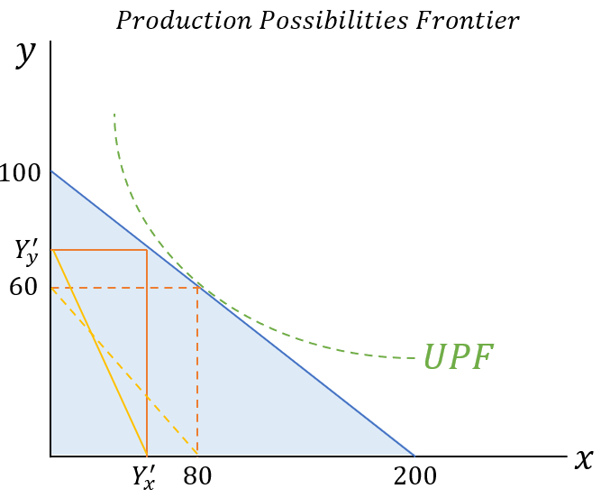

Figure 2

Figure 2 shows the economy when good $x$ is produced by a monopolist. The output for good $x$, $Y_{x}^{'}$, is less than its previous Pareto optimal level of output 80, while the output of good $y$, $Y_{y}^{'}$, is above its previous Pareto optimal level of output 60. The budget line, shaded in yellow, has steepened and is no longer parallel to the PPF, indicating that prices no longer give information of the relative scarcity of goods. As a result, the cost of consumption is not aligned with the cost of production and the extra labour needed to make good $y$ is not reflected in the relative price between good $x$ and good $y$– consumers therefore divert more social labour toward the production of good $y$ even when that labour would be better served, in terms of final utility, working to produce good $x$.

1. **Set out and briefly explain the necessary conditions and assumptions needed to achieve Pareto optimality. Bearing in mind the doubts expressed by Blaug in the quote below, do you think the First and Second Fundamental Welfare theorems have anything useful to offer in terms of policy guidance? (55 marks)**

The first assumption needed to achieve Pareto optimality is that the economy contains only utility maximising individuals and profit maximising firms. These individuals and firms are price takers, i.e., no individual or firm has enough market power to modify prices, instead taking them as given. Individuals have perfect knowledge and therefore are aware of other individuals’ utility functions and their own. Individuals’ utility functions do not depend on the consumption of other individuals or the production decisions of firms, i.e., there are no production or consumption externalities wherein third parties are unintentionally affected by a decision. There are no taxes or subsidies, meaning that prices are not distorted from market prices – this does not preclude the possibility of lump-sum, or non-distortionary, taxation. Finally, returns to scale must be non-increasing, as this, coupled with convex indifference and isoquant curves, allows unique equilibria to be determined across all sectors.

When these assumptions are satisfied, the resulting consumption and production decisions and resulting resource allocation will be Pareto optimal. An allocation is Pareto optimal, or efficient, when no individual can be made better-off without making another individual worse-off. Pareto improvements are possible when individuals could be better off at no-one’s expense. Furthermore, the First and Second Fundamental Welfare Theorems will hold; first, the general equilibrium of the competitive economy is necessarily Pareto efficient; second, any Pareto efficient allocation can be achieved as the outcome of a competitive general equilibrium following a suitable redistribution of initial endowments.

I believe that the First and Second Fundamental Welfare Theorems do have utility in terms of policy guidance, although Blaug presents an important point that, ultimately, their practical applicability is limited.

First, it is important to recognise that an unrealistic model can still be useful given that we know where its discrepancies with reality lie. For example, the above assumptions, like the assumptions underlying perfect competition, require perfect knowledge of consumers. While this is clearly an impractical, knowing that it is a pre-requisite for the general equilibrium model means that we know what specific areas should be targeted as policy objectives, viz., reducing information asymmetry, making the model still a useful point of reference. Furthermore, by being explicit in their limitations, the First and Second Fundamental Welfare Theorems can inform us of situations where they should not be expected to hold, e.g., monopoly, and how we should modify our expectations of these situations going forward; in fact, analysing general equilibria when certain assumptions are not satisfied provides strong theoretical underpinnings for why policy should aim to fulfil those assumptions.

Second, I find that while the Second Fundamental Welfare Theorem clearly has some practical limitations, the clearest of which is the infeasibility of lump-sum taxation, the general heuristic it provides is a sound reference point for policymaking. That heuristic is, that prices generally reflect the marginal cost of goods, and should not be distorted via policy to give one group more or less relative purchasing power. Instead, if it is socially desirable to redistribute purchasing power, then this should be done directly via income or wealth redistribution. When prices are modified, consumers influence the production process by consuming goods in new, different relative quantities – this is not the case when endowments are redistributed and prices are left as they are. Of course, the practicality of lump-sum taxation is extremely dubious given that taxation would have to be on the basis of some immutable characteristics – if it were not, consumption and production decisions would again be distorted by individuals recalculating their utility functions with forward-looking tax-liabilities. However, I do not believe this impracticality is enough to render the Second Fundamental Theorem a useless reference point. Instead, it seems clear to me that, if the idea of reducing distortions is desirable, then the Second Fundamental Theorem should not be discarded, but instead kept to point us in a direction where income and wealth taxes are as non-distortionary as possible to ensure prices still convey marginal cost information easily to consumers.

In conclusion, it is precisely because the First and Second Fundamental Welfare Theorems are theoretically desirable but realistically impractical, that I believe they should be used as *reference* points. Blaug suggests that something ‘patently impractical’ should be discarded as a reference point, whereas I find that, given reference points can be used to provide a general goal or direction, the First and Second Theorems, and their underlying assumptions, fit this role quite well. The First Theorem indicates that, as we approach our initial assumptions, e.g., few information asymmetries and more competitive markets, market equilibria will approach Pareto optimality. The Second Theorem indicates that Pareto optimality is better conserved when initial endowments, rather than prices, are modified. While lump-sum taxation to redistributed initial endowments is likely infeasible, it still provides a policy goal of finetuning tax-codes to be as non-distortionary as possible. In my opinion, these concrete suggestions indicate the Theorems are useful as reference, rather than *end*, points.